INSTRUCTIONS: This is an SOP template; it is complete when
1) All form fields have been completed to reflect chemical/lab-specific information, including adding relevant procedure information, or deleted inapplicable information; and
2) SOP has been signed and dated by the PI and relevant lab personnel.
Use safety data sheets (SDSs) as a resource for chemical-specific information. Text highlighted in gray indicates where information should be added or edited. Delete all instructions in red text and “Draft” watermark after the SOP is approved by PI.
Standard Operating Procedure
Sodium Azide
Print a copy and insert into your Lab-Specific Chemical Hygiene Plan.
Section 1 – Lab-Specific Information
Building/Room(s) covered by this SOP:
Unit or department:
Principal Investigator Name:
Principal Investigator Signature/Date:
This SOP was created by (if not PI):
Name/Title/Date/Signature:

Section 2 – Hazards
Sodium azide may be harmful if inhaled. It may cause respiratory tract, skin, and eye irritation and may be fatal if absorbed through skin or swallowed. Sodium azide can react with metal spatulas and metal lab equipment to form shock sensitive salts. Sodium azide reacts with Lead, Copper, Silver, Gold and metal halides to form heavy metal azides which are explosive. Additionally, contact with acids liberates toxic gas.
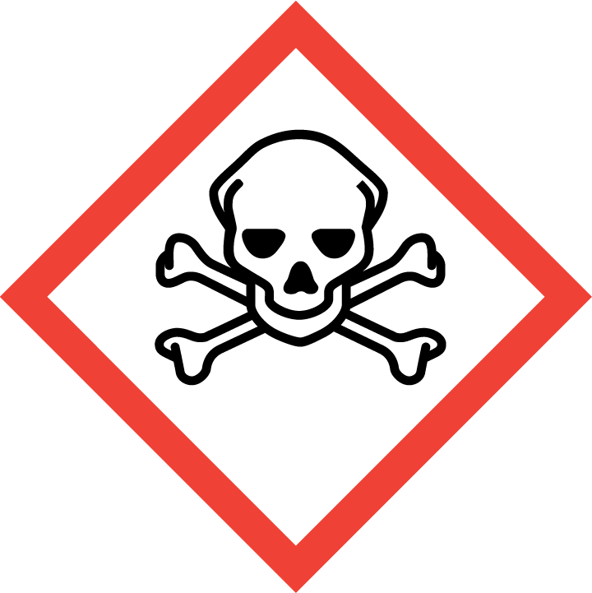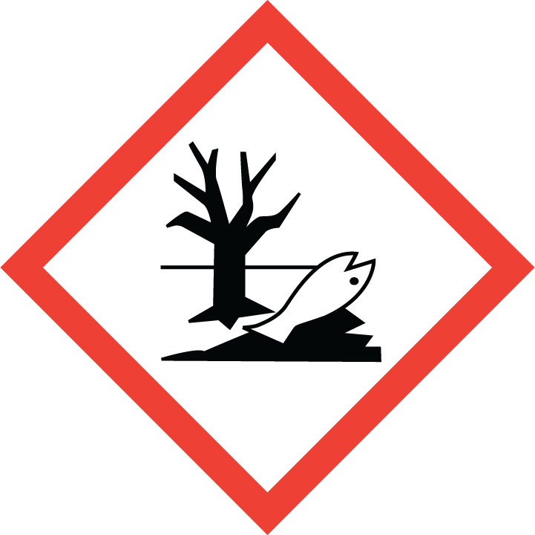
Section 3 – Engineering and Personal Protective Equipment (PPE)
Engineering Controls: Use of sodium azide should be conducted in a properly functioning chemical fume hood whenever possible. The chemical fume hood must be approved and certified by REM and have a face velocity between 80 – 125 feet per minute.
Hygiene Measures: Avoid contact with skin, eyes, and clothing. Wash hands before breaks and immediately after handling the product.
Hand Protection: Chemical-resistant gloves must be worn, nitrile or chloroprene gloves are recommended. Double-gloving is recommended when working with pure sodium azide or sodium azide solutions greater than 5%. NOTE: Consult with your preferred glove manufacturer to ensure that the gloves you plan on using are compatible with the specific chemical being used.
Eye Protection: ANSI approved properly fitting safety glasses or chemical splash goggles are required. A face shield may also be appropriate depending on the specific application.
Skin and Body Protection: Laboratory coats must be worn and be appropriately sized for the individual and buttoned to their full length. Personnel must also wear full length pants, or equivalent, and close-toed shoes. Full length pants and close-toed shoes must be worn at all times by all individuals that are occupying the laboratory area. The area of skin between the shoe and ankle must not be exposed.
Respiratory Protection: If sodium azide is being used outside of a chemical fume hood, respiratory protection may be required.. If this activity is necessary, contact EH&S at 206.543.7388 so a respiratory protection analysis can be performed.

Section 4 – Special Handling and Storage Requirements
- Do not over purchase; only purchase what can be safely stored in the laboratory.
- Any expired or unnecessary sodium azide should be properly disposed of as hazardous waste.
- Pure sodium azide should be clearly labeled with the original manufacturer’s label, which should have the chemical name, hazard labels, and pictograms. The label should not be defaced in any way.
- Make stock solutions of 10%, if possible, to minimize potential accidents.
- Whenever handling pure sodium azide powder or concentrated solutions of ≥10% that may require assistance in case of a spill or accident, it is recommended that a second trained individual be present in the lab or in the vicinity.
- Store sodium azide in secondary containment with “Acute Toxin” label on the primary container, secondary containment and the storage location.
- Do not store on metal shelves or use metal items (spatulas) to handle sodium azide.
- Keep containers tightly closed. Store in a cool, dry, and well-ventilated area away from incompatible substances such as metals, acids, carbon disulfide, bromine, chromyl chloride, sulfuric acid, nitric acid, hydrazine, and dimethyl sulfate.
- Avoid contact with skin, eyes, and inhalation. Avoid formation of dusts and aerosols.

Section 5 – Spill and Accident Procedures
If skin is exposed to sodium azide, remove contaminated clothing and shoes, rinse for 15 minutes in the safety shower. Send someone to call 911 as soon as possible. If eye is exposed to sodium azide, call 911 as soon as possible and flush eyes for 15 minutes in the eye wash, continue rinsing eyes during transport to hospital. If sodium azide is inhaled, remove to fresh air and call 911. Bring Safety Data Sheet (SDS) with you to show medical personnel.
Immediately evacuate area and ensure others are aware of the spill. During normal business hours (Monday – Friday, 8 AM – 5 PM), call EH&S at 206.543.0467 for further assistance. If it is after hours, call 911 for further assistance. If it is safe to clean up the spill, wear PPE listed above. Double bag and securely fasten spill materials. Label as hazardous waste.
Report the spill via the EH&S Online Accident Reporting System (OARS).

Section 6 – Waste Disposal Procedures
Store hazardous waste in closed containers that are properly labeled, and in a designated area (flammable cabinet is recommended) away from incompatible chemicals such as metals and those listen above. The spill materials cannot go in the trash or down the drain. Request chemical waste collection via the EH&S website immediately.

Section 7 – Protocol
Click here to enter text.
NOTE: Any deviation from this SOP requires approval from Principal Investigator.

Section 8 – Documentation of Training (signature of all users is required)
Prior to conducting any work with hydrochloric acid, the Principal Investigator must ensure that all laboratory personnel receive training on the content of this SOP.
I have read and understand the content of this SOP:
Name | Signature | Date

